**Dry Run Creek Urban vs. Rural Surficial Water Quality Variability**

Austin Cox & Nick Bosshart

Field & Laboratory Methods in Hydrology

University of Northern Iowa

December 7, 2011

**Abstract**

Our investigation into rural vs. urban surficial water quality variation of Dry Run Creek has yielded some interesting results. Analysis of two sites (one rural, one urban) along the same stream, on the basis of temperature, pH, T.D.S. (total dissolved solids), D.O. (dissolved oxygen) content, and B.O.D. (biochemical oxygen demand), has illustrated some contrast in all of our analysis criteria (more simply: urbanization, of Cedar Falls, appears to have a strong, multi-dimensional effect on the streams flowing through).

**Introduction**

The primary emphasis of our study was to highlight the differences in surficial water quality of rural water in comparison with urban water, specifically in the Dry Run Creek drainage system. We selected two sites, one that would give us a good representation of the characteristics of rural water quality before the stream passes through the Cedar Falls metropolitan area and another giving fair representation of urban water quality (after the stream had undergone any changes from the transit through Cedar Falls). Our next step was to select the feasible, testable criteria in order to produce meaningful results.

The criteria of our investigation was determined by two factors: the scope of aspects of water quality we had the ability to test and which testable aspects would have the most variability from external influence between the upstream rural site and the downstream urban site. Rural water (in agricultural areas) sometimes exhibits particular problems that have warranted much study, but our focus was really to see how an urban setting can affect the quality of water in a stream.

We compiled a list of water quality aspects we had the capability to test for. We used the knowledge gained from our class activities throughout the year and other previous field studies to determine which testable water quality aspects would exhibit the greatest change from a stream’s transit into and through an urban environment. The variables we decided upon included: temperature, pH, T.D.S. (total dissolved solids), D.O. (dissolved oxygen) content, and B.O.D. (biochemical oxygen demand). We also decided it was necessary to obtain at least six data sets (and, ideally, at least one data set immediately following a precipitation event) in order to have enough data to produce graphical comparisons with which we could illustrate our results. These results would then enable us to draw conclusions as to what exactly is contributing to the observed differences, and how could an individual utilize these results to initiate further field studies in future investigations.

Going into further detail on our site selection process, we reached into our resources and found a map of the Dry Run Creek drainage system in the UNI database (see Appendix-Figure 1). This map showed all the branches of Dry Run Creek, from its upmost reaches to its confluence with the Cedar River in Cedar Falls. This gave us visibility of possible sampling/testing sites, and an estimation of the amount of travel we could expect in visiting those sites. The map, being a product of previous research, highlighted many sites that had been tested before (indicating sites that were good for testing with ease of accessibility). Along with the drainage testing sites, the map (as a generated aerial photo) gave us the ability to view, in great detail, the land surrounding and adjacent to Dry Run Creek. Utilizing this resource, we were able pinpoint specific branches of the Dry Run Creek drainage system that would potentially have the most variability in water quality characteristics (pertaining to rural vs. urban contrast).

After taking all of the information above into account, we selected UNI Testing Site Four for our rural testing area (see Appendix-Figures 2-4), and UNI Testing Site Eight for our urban testing area (see Appendix-Figures 5-6). Site Four is located on Union Road outside the Cedar Falls city limits and is adjacent to agricultural ground and woodland. This branch of Dry Run Creek flows primarily through soil, sand, and silt, with rocks protruding from the banks where erosion is most prevalent. Nearly all of the water entering the drainage at this section of the creek is of agricultural ground origin. Site Eight is located near the Cedar Falls Utilities plant on Waterloo Road, not far from the downtown area and only a few hundred yards from its confluence with the Cedar River. Site Eight is approximately three miles northeast/downstream of Site Four (direct distance). This branch of Dry Run Creek passes through an urban setting, both commercial and residential, for over a mile by the time it reaches Site Eight. The creek flows immediately past several construction sites and is confined in several areas with cement embankments. Both sites, we felt, were valid and would yield meaningful results for each testing field of our investigation.

Upon visiting our rural site (Site Four) for testing, we discovered there to be a rock dam nearby, causing the upstream side to be nearly stagnant. This had both of us raising questions as to which side of the dam to test, knowing that it could potentially make a difference in our results. One of the questions we posed was: what differences in water quality characteristics could we observe when testing from the stagnant pool or the downstream side? This unknown was important enough for us to add a sub-study within our primary study. We altered our sampling and testing procedure at Site Four, sampling both the upstream (stagnant) side of the dam and the downstream side of the dam for the same criteria we had selected for our primary study. This would both give us the fair comparison between urban and rural water quality (what we were looking for initially) and also give us insight as to what effects dam structures impose on this stream (and other similar streams).

**Hypothesis**

After selecting our sampling/testing criteria, we drew a hypothesis for each by discussing what we anticipated to obtain for results.

We predicted the temperature of the stream would increase during transit from Site Four to Site Eight. This difference in temperature would likely be produced by further sun exposure, heat transfer from the ground, and possibly from the addition of treated commercial drainage directly into the stream.

We weren’t sure how much variance we would observe in pH, but the presence of a few construction sites adjacent to the stream’s bank between our testing sites and limestone bank rubble led us to believe we would see a rise in pH with the stream’s progression from Site Four to Site Eight.

We hypothesized that T.D.S. (total dissolved solids) would likely increase with progression downstream from Site Four to Site Eight. This hypothesis was based on the knowledge that the stream would experience further open bank exposure during its transit and also the addition of storm drain water from the Cedar Falls roads.

We believed the dissolved oxygen content of the stream water would increase with progression downstream from Site Four to Site Eight. We hypothesized the water would have increased exposure to bank vegetation and algae, as well as having more opportunity to aerate via spillways and outlets.

We predicted the B.O.D. (biochemical oxygen demand) would also increase from the stream’s transit from Site Four to Site Eight. We suspected the water would acquire more bacteria and nutrients (for bacteria to metabolize) from commercial & residential outlets and runoff during transit.

**Field Methods**

When it came time to go out into the field to collect our data, we wanted to be mobile and pack as light as possible. We needed to find a way to get our D.O. (dissolved oxygen), pH, and T.D.S. (total dissolved solids) meters, sampling containers (to bring water back to the lab to test biochemical oxygen demand), and our data sheets (for recording sample test results) out into the field with some organization. It was a lot of equipment to take out to both of our sites, which contained some uneasy walking surfaces. We utilized plastic totes from our hydrology lab to transport the necessary equipment. We were able to easily carry our analysis tools from truck to site, and it made the testing process much more efficient.

Pertaining to the testing itself, we picked specific spots within the site that we would test each and every time we visited. In doing this, we were able to decrease the potential for variability of results stemming from testing/sampling methods. We made sure to sample locations that would fairly represent the site. We visited each site twice a week for three weeks. Our reasoning behind this is we didn’t want to track seasonal changes in the water’s quality; instead we were interested in highlighting the difference in the water at any given instance. Since we did our testing during the fall, we did have a lot of temperature variance through our three weeks. However, both sites were tested within minutes of each other to assure we were getting the numbers we wanted for comparison.

**Laboratory Methods**

The laboratory methods we utilized during our investigation were relatively simple, consisting of five-day D.O. (dissolved oxygen) and B.O.D. (biochemical oxygen demand) calculation.

The water samples we collected from the Dry Run Creek sites were brought back to the lab and stored in a room-temperature, dark location for five days. After five days the samples were tested using a D.O. (dissolved oxygen) meter. The dissolved oxygen content after five days was expected to be decreased from the initial sample measurement, due to utilization of oxygen during the metabolism process of bacteria.

The measured five-day dissolved oxygen content was then subtracted from the initial measured dissolved oxygen content. The difference observed between the two measurements (the amount of oxygen metabolized by bacteria during 5 days) was annotated as the sample’s B.O.D. (biochemical oxygen demand).

**Data**

Our sampling and testing data has been compiled below (charts are in sample date sequence, sites within the charts are separated by columns).











**There was a rain event immediately prior to our sampling on 11/2/2011; some notable differences were observed during graphical analysis of results.



**Results & Discussion**

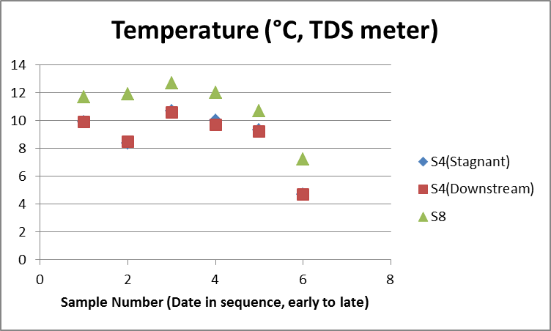

Along with an overall trend of decrease in temperature among all sites (sampling took place in October & November as temperature was decreasing), graphical analysis of temperature measurements illustrates a strong trend of temperature increase during transit from rural environment to urban environment. All of our data sets agree with this trend; Site Eight temperature was consistently higher than Site Four temperature.

Pertaining to our sub-study within Site Four, no notable differences were observed between the stagnant pool and downstream.

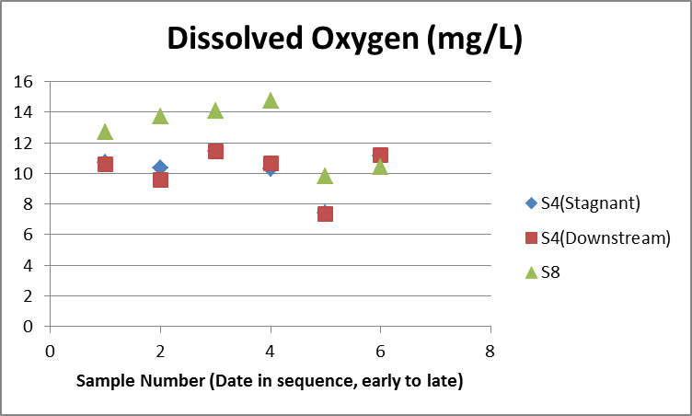

Graphical analysis of dissolved oxygen measurements reveals a fairly strong trend of increasing dissolved oxygen content during transit from rural environment to urban environment; Site Eight generally measured higher in dissolved oxygen content than Site Four. All of our datasets but one agree with this trend.

Also notable is a sharp decrease in dissolved oxygen content in the fifth data set. We believe this decrease to be correlated with the rain event preceding our sampling on that particular date.

Pertaining to our sub-study within Site Four, no notable differences were observed in dissolved oxygen content between the stagnant pool and downstream.

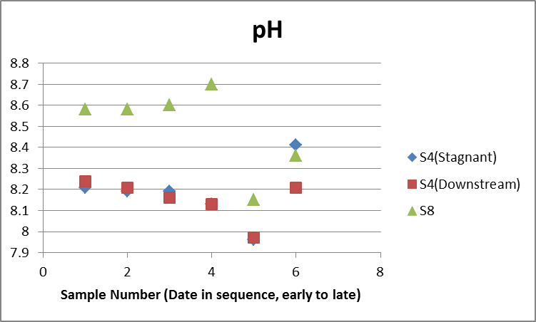

Graphical analysis of sample pH reveals a general trend of increasing alkalinity during transit from rural environment to urban environment (with the exception of our last data set); Site Eight generally had a higher pH than Site Four.

We noticed a sharp drop in pH during our fifth data set (likely in correlation with the rain event preceding our sampling that day).

Pertaining to our sub-study within Site Four, pH measurements for the stagnant pool and downstream were generally very similar with the exception of our last data set. The sixth data set shows a sharp contrast that is somewhat perplexing.

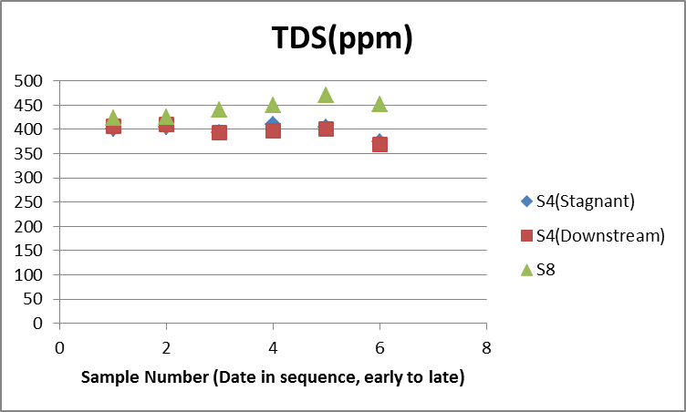

Graphical analysis of T.D.S. concentrations shows a strong trend of increasing dissolved solid content during transit from rural environment to urban environment; Site Eight dissolved solid content was consistently higher than Site Four dissolved solid content.

Pertaining to our sub-study within Site Four, no notable differences were observed between the stagnant pool and downstream.

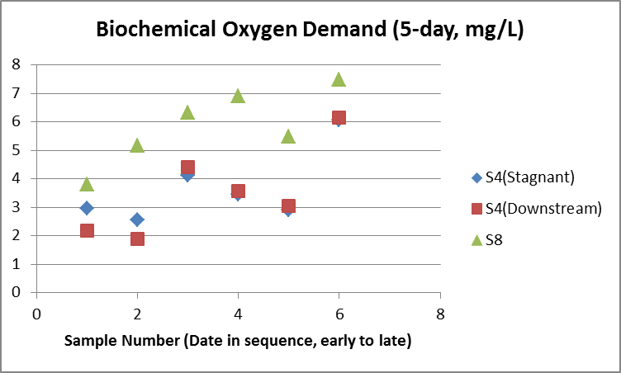

Graphical analysis of B.O.D. shows a strong trend in increasing value during transit from rural environment to urban environment; Site Eight B.O.D. measurements were consistently higher than Site Four B.O.D. measurements.

A small decrease in B.O.D. measurement was observed in our fifth data set (likely in correlation with the rain event preceding our sampling).

Pertaining to our sub-study within Site Four, we noticed some variation between the stagnant pool B.O.D. and the downstream B.O.D. in our first three data sets. The B.O.D. measurements between the two seemed to become more similar with each successive data set. The differences observed early on in the investigation may possibly have been interlinked with temperature (temperature was starting to decrease as the investigation proceeded from October to November).

**Discussion**

So, what did we find out? And what does all this mean?

* strong trend of temperature increase during transit from rural environment to urban environment
* fairly strong trend of increasing dissolved oxygen content during transit from rural environment to urban environment
* general trend of increasing alkalinity during transit from rural environment to urban environment
* strong trend of increasing dissolved solid content during transit from rural environment to urban environment
* strong trend in increasing B.O.D. value during transit from rural environment to urban environment

The criteria we tested for (temperature, dissolved oxygen, pH, TDS, and B.O.D.) all show variance between rural environments and urban environments. The appearance of these results is that our societies and urbanization may have a profound effect on certain aspects of water quality. However, there are some other explanations that need to be considered:

* Increasing temperature trend may be attributed to the duration of time the water stays in the drainage system (the longer the water is on the ground, the warmer it may become; not necessarily a sharp difference between rural and urban environments).
* Dissolved oxygen content may be a more complex issue (temperature, amount of nitrates & algae present, type & number of flora present, bacterial levels, and degree of aeration would all have effects on dissolved oxygen content).
* Our pH results may be correlated somewhat with elevation (the lower the elevation, the more likely the water is to come into contact with Iowa bedrock/limestone).
* pH may also be correlated with bank stability and the prevalence of limestone rubble used to secure and stabilize.
* TDS concentration increase is likely to increase with urbanization, but other tests should be done to pinpoint the identity of the constituents being introduced (such as utilizing ion chromatography analysis).

**Conclusion**

Our investigation into the differences observed between the rural environment and urban environment along Dry Run Creek yielded good, scientific results. The scope of our investigation was multi-dimensional, yet not overwhelming. Our sites, sampling criteria, and analysis methods were all strategized to produce meaningful data. We conducted the investigation in an impartial, unbiased, methodical manner (to the best of our knowledge and ability). The data we obtained was represented in a simple, straightforward manner for ease of assimilation and understanding. We’ve listed some other possible explanations and alibis for the observed differences in order to encompass the full spectrum of potentialities. The main descendant of our investigation is that differences have been noted in the same stream during transition from a rural environment to an urban environment. These observed differences are, of course, preliminary. Further study in the Dry Run Creek drainage system would be helpful to more fully understand the variation and corroborate our results.

**Appendix: Site Pictures**

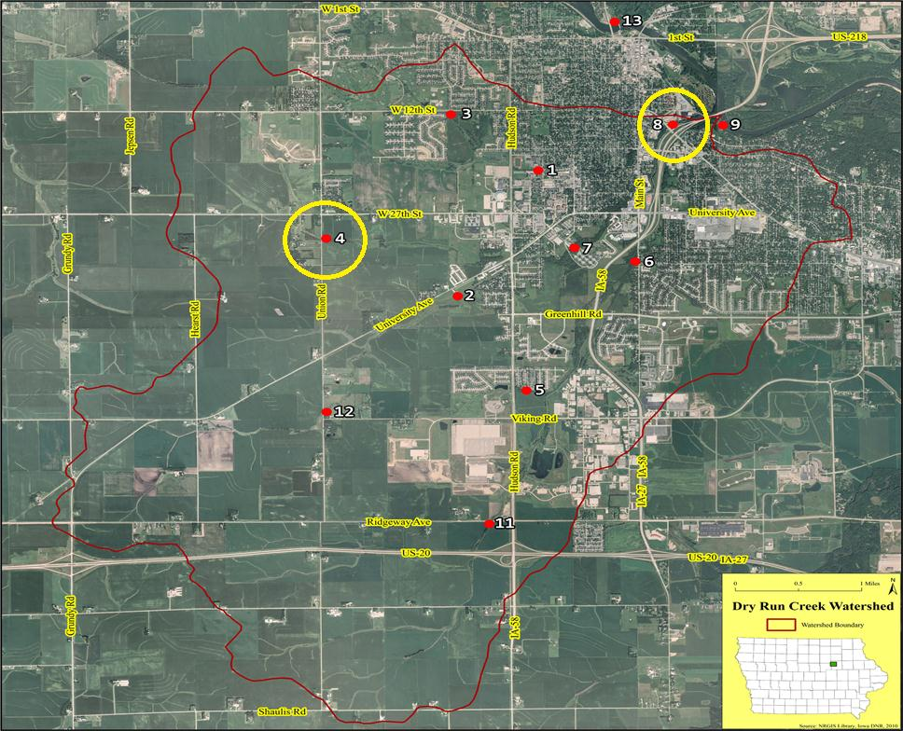

**Figure 1. UNI Testing Site Map**

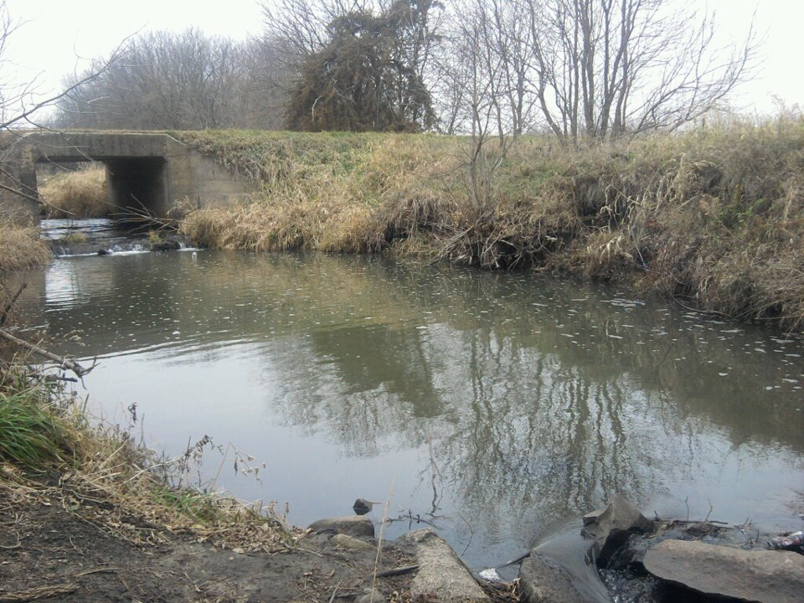

**Figure 2. Site Four-Stagnant Pool**

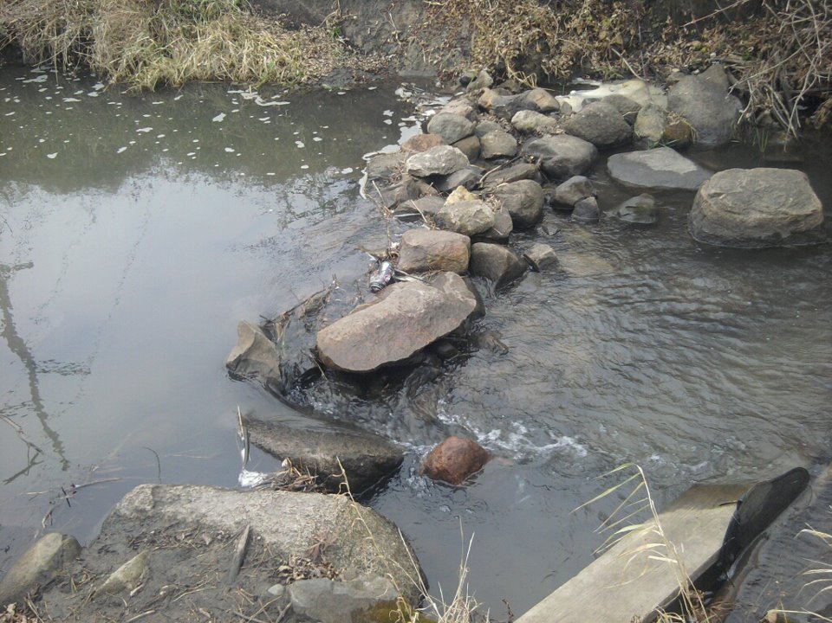

**Figure 3. Site Four-Rock Dam**

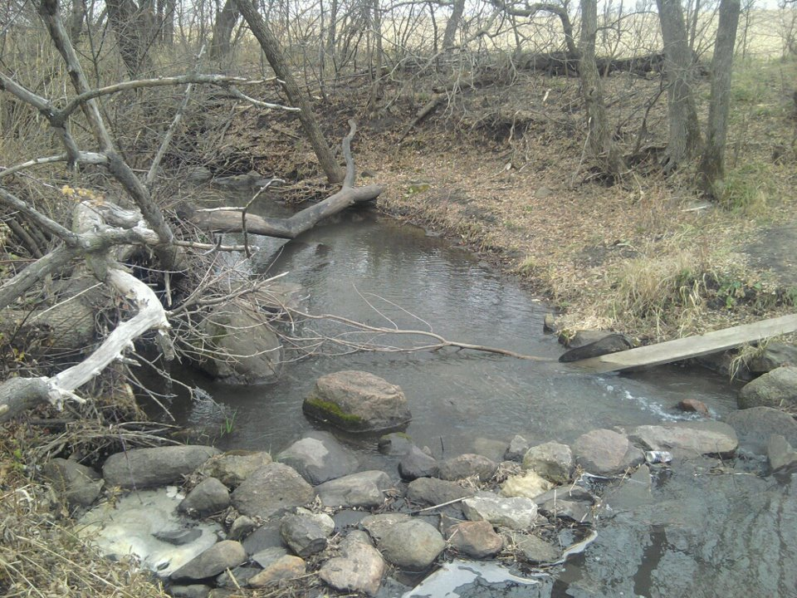

**Figure 4. Site Four-Downstream**

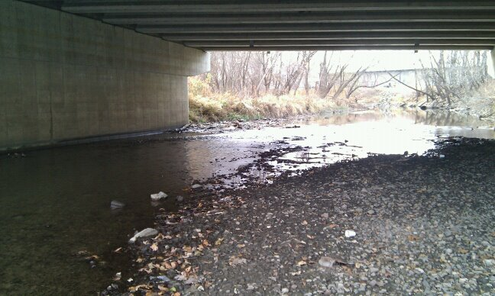

**Figure 5. Site Eight looking upstream**

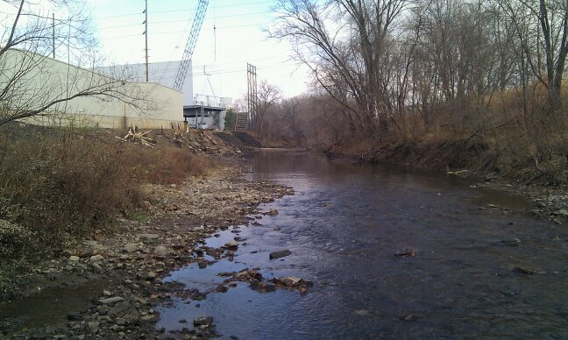

**Figure 6. Site Eight looking downstream**

**Resources**

Data collected by Austin Cox & Nick Bosshart.

Pictures taken by Austin Cox & Nick Bosshart.

UNI Testing Site Map. University of Northern Iowa Hydrology Research Website. Adapted from

“Water Quality Data”. Retrieved on 27 November 2011 from http://www.uni.edu/hydrology/DRC_Map.html